RAYAGADA INSTITUTE OF TECHNOLOGY AND MANAGEMENT, RAYAGADA-765002

Mandatory Disclosure (2025-26)

- AICTE File No. : F.No. Eastern/1-46209957697/2026/EOA
Date & Period of last Approval : 16-Mar-2026
RAYAGADA INSTITUTE OF TECHNOLOGY
- Name of the Institution : AND MANAGEMENT
Address of the Institution : PITAMAHAL
City & Pin Code : RAYAGADA, 765002
State / UT : ODISHA
Mobile Number with STD Code : +91 8114772618, 8984133042 Office hours at the Institution : 8.00 am – 5.00 pm
Academic hours at the Institution : 8.30 am – 4.20 pm
Email : ritamprincipal@gmail.com
Website : www.ritamrayagada.in
Nearest Railway Station : Rayagada
Nearest Airport : Vishakhapatnam

- Type of the Institution : Private. Aided

- Name of the organization
running the Institution : Bhagawan Shri Gyan Vikash Charitable
Type of the organization : Trust
Address of the organization : Vamsi Krishna Hotel, Rayagada-765002 Registered with : Court of Rayagada
Registration date : 05.11.2008
- Name of the affiliating University : Biju Patnaik University of Technology Address : Chhend Colony, Rourkela, Odisha
Website : www.bput.ac.in
Latest affiliation period : 2023-24
- Name of the Principal / Director : Dr S. Srinivasan
Exact Designation : Principal
Phone number : 7008900453
Email : ritamprincipal@gmail.com
Highest Degree : PhD
Field of Specialization : Thermal Engineering
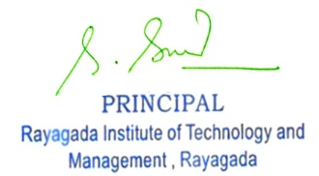

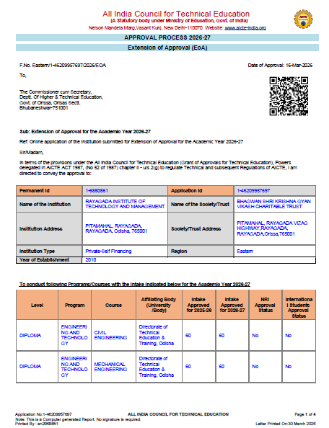

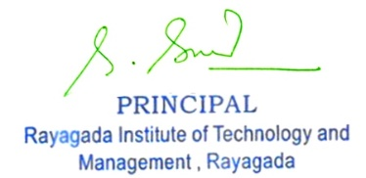

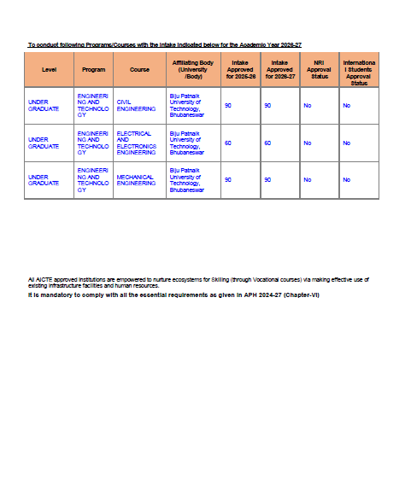

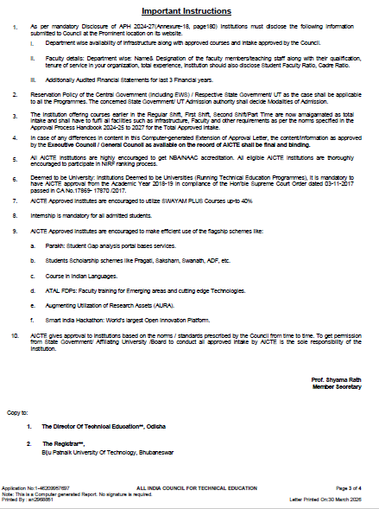

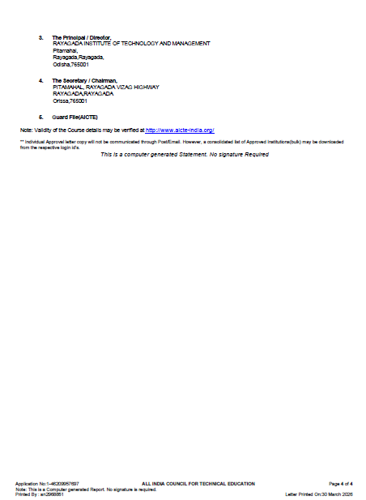

- Governing Council Members :

Sl.No. | Name | Position | Qualification | Present  Designation / Occupation | Telephone numbers | E-mail
1 | Sri. Kona Mohan Rao | Chairman | BCom | Managing Trustee | 9437023179 | Mohan123@gma il.com
2 | Sri. Krishna Ch. Mohapatra | Secretary Management | MBA | Founder Trustee | 9437214560 | kcmahapatra@g mail.com
3 | Sri. B.V.Ravi Kumar | Treasurer Trust | MBA | Tresurer Trustee | 7978571287 | Bvravi143@gmai l.com
4 | Smt. Kona Jagadiswari | Member / Management | PhD | Trustee Member | 9444771682 | Ritam333@gmail  .com
5 | Smt. Narayanachetty Roja | Member / Management | BE | Trustee Member | 9338562145 | Ritam333@gmail  .com
6 | Sri. Ashok Kumar Sharda | Member / Management | PhD | Trustee Member | 9437000635 | aksharda@gmail  .com
7 | Smt. Sanjukta Sharda | Member / Management | IAS | Trustee Member | 7005600213 | ssharda@yahoo. co.in
8 | Dr . S.Srinivasan | PRINCIPAL | PhD | Principal | 8455812569 | ritamprincipal@g mail.com
9 | Sri. P.C.Hota | Member / Management | IAS | Former UPSC Chairman New Delhi | 044 28275650 | Hota_pc@gmail. com
10 | Prof Dr. Aditya Prasad Padhi | Member / Management | PhD | Former Vice-Chancellor, Berhampur University | 93632 27757 | vcbu@bu.edu.in
11 | Mr. S.K.Mishra | Member / Management | M.Tech, MBA | CEO & MD Utkal Aluminium Ltd | 09414491729 | Mishra1@y ahoo.co.in
12 | Dr. Mukesh Kumar | Member / Management | M.Tech, MBA | CEO Vedanta Aluminium, Lanjigarh, Odisha | 9840123290 | ceo@gmail.com
13 | Mr. G.P.Rao | Member / Management | MBA | VP(HRD) Reliance Industries, Kualampur, Malaysia | 0422 4344777 | Raogp11@gmail. com
 |  |  |  |  | (4147)
 |  |  |  | Indira Priya Darshini Vrikshamitra Award |  | Mohapatra1961
14 | Mr. Gadadhara Mohapatra |  | IFS |  | 0422 4344777 | @gmail.com
 |  | Member / |  |  | (4169)
 |  | Management
15 | Prof. Kishan Kumar | Faculty member from | PhD | Head of Department | 0422 4344777 | vpprincipal@
 |  | the Institution |  |  |  | Gmail.com
 |  | at Professor
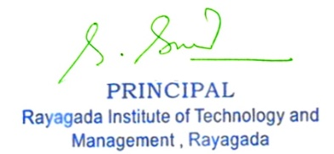

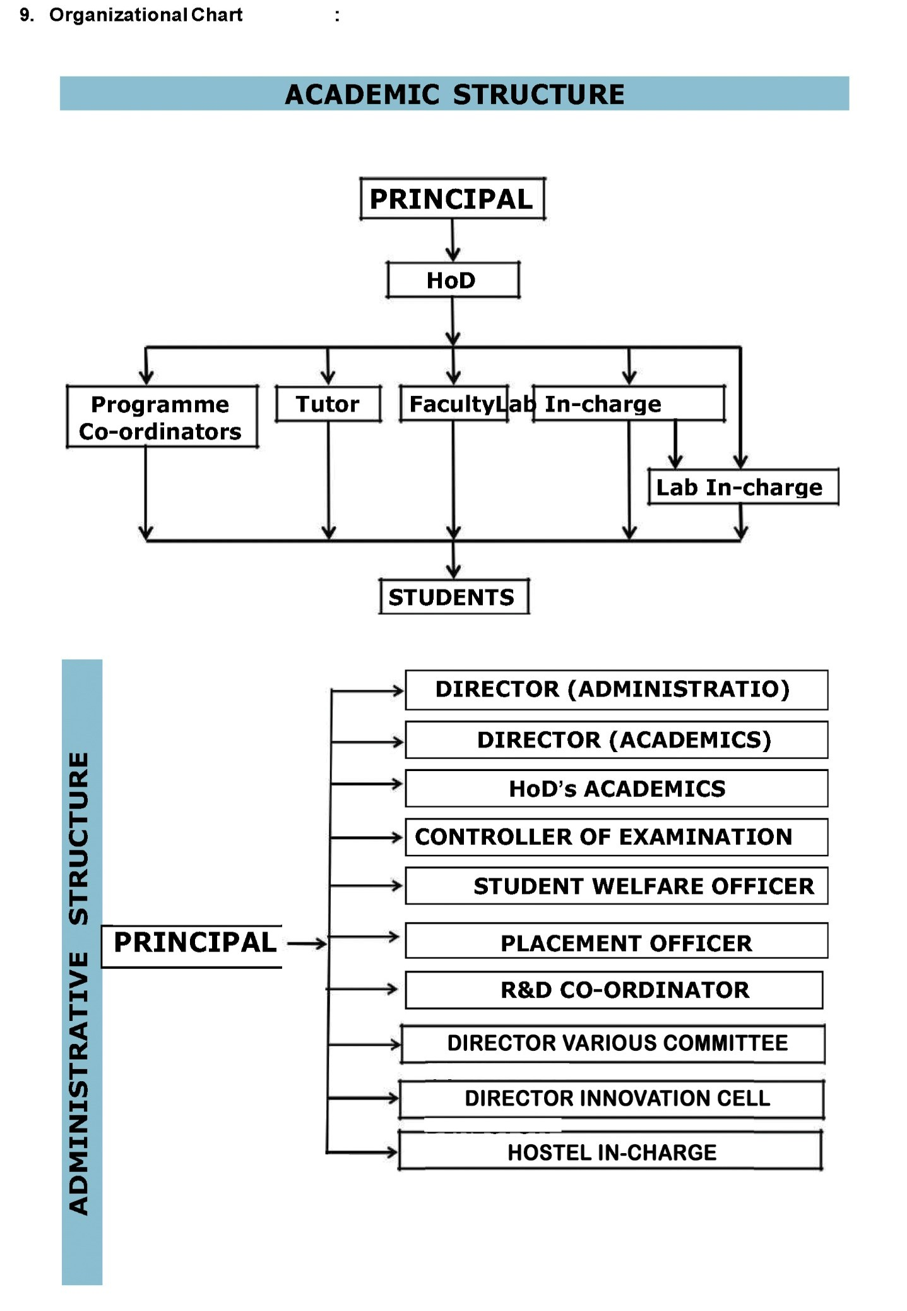

- Student feedback mechanism on Institutional Governance / faculty performance

FEEDBACK QUESTIONS

Theory Questions:

%□ Punctual to the class and engages for full hour
%□ Has clarity of expression and an audible voice
%□ Presents the subject matter clearly
%□ Encourages the students to actively participate in the class activities (through interaction question/ answers, clearing of doubts, etc)
%□ Relates the subject matter with practical examples
%□ Gives assignment / seminars / tutorials and monitors them
%□ Returns the valued internal test papers within 10 days
%□ Completes the syllabus in time
%□ Available to assist students outside the class hours
%□ Motivates the students to learn and creates interest

Lab Questions:

Punctual to the laboratory and enthusiastic in the lab class Has clarity of expression and an audible voice
Relates the theory behind the experiment with the objectives
Encourages the students to actively participate in the lab activities (through appropriate questions and clearing of doubts, etc)
Relates the outcome of the experiment with practical examples or applications provides additional input during the monitoring process of the experiments The evaluation process is objective and transparent
Provides adequate opportunities for the students to complete the cycle of experiments Available to assist the students outside the lab hours
Motivates the students to learn and creates interest among them in the lab

Anti-Ragging Committee/Squad Details
Sl. No | Commi ttee Type | Appoint ment Order referenc  e Number | Date of Appoint ment | Name of the Committee Member | Profession | Addres s | Associated With | Mobile Number | Fax No. | e -Mail Address
1 | Grievan ce  Redres sal | RITAM/1 400 | 02/07/20  17 | PROF. S. SRINIVASA N | PRINCIPAL | RITAM, RAYAG ADA | RITAM | 966626  7026 |  | singuluri.sriniva san@gmail.co m
2 | Anti- Raggin  g Squad | RITAM/1 400 | 02/07/20  17 | PROF. S. SRINIVASA N | PRINCIPAL | RITAM, RAYAG ADA | RITAM | 966626  7026 |  | singuluri.sriniva san@gmail.co m
3 | Anti- Raggin g Commit  tee | RTM/AD  MN/ 177 | 02/02/20  13 | SRI SAHADABA CHOUDHUR Y | SR. ADVOCAT E | RAYAG ADA | RAYAGAD A COURT | 685622  2103 |  | Sahadaba23@gm ail.com
4 | Anti- Raggin g  Commit tee | RTM/AD  MN/ 177 | 02/02/20  13 | SRI BISNU PRASADSA HOO | Police Admin(I/C) | RAYAG ADA | RAYAGAD A POLICE STATION | 943777  6633 |  | ritam333@gmail.c om
5 | Anti- Raggin g Commit  tee | RTM/AD  MN/ 177 | 02/02/20  13 | SRIK.K.JEN A | Local Media | RAYAG ADA |  | 943711  8869 |  | kkjena176@yahoo  .com
6 | Anti- Raggin g Commit  tee | RTM/AD  MN/ 177 | 02/02/20  13 | SRI JAYARAM JENA | NGO REPRESE NTATIVE | RAYAG ADA |  | 943782  1951 |  | shaktijena@rediff mail.com
7 | Anti- Raggin g  Commit tee | RITAM/1 400 | 02/07/20  17 | MR. RAMESH TELAGAMS ETTI | Assoc. Prof. (CIVIL) | RAYAG ADA | RITAM | 845581  3189 |  | ritam333@gmail.c om
8 | Anti- Raggin g Commit  tee | RITAM/1 400 | 02/07/20  17 | MR A.K. NAYAK | Asst. Prof. (EEE) | RAYAG ADA | RITAM | 943777  1175 |  | ashishjitm@gmail. com
9 | Anti- Raggin g  Commit tee | RTM/AD  MN/ 177 | 02/02/20  13 | MR.KISHAN KUMAR | Asst.  Prof.(MATH  ) | RAYAG ADA | RITAM | 943993  4972 |  | ladikishan@yahoo  .co.in
10 | Anti- Raggin  g Squad | RITAM/1 401 | 02/07/20  17 | MR. RAMESH  TELAGAMS ETTI | Assoc. Prof. (CIVIL) | RAYAG ADA | RITAM | 845581  3189 |  | ritam333@gmail.c om
11 | Anti- Raggin g  Squad | RITAM/1 401 | 02/07/20  17 | MR. A.K. NAYAK | Asst. Prof. (EEE) | RAYAG ADA | RITAM | 943777  1175 |  | ashishjitm@gmail. com
12 | Anti- Raggin g  Squad | RITAM/1 401 | 02/07/20  17 | MR. B RAJ KUMAR | Asst.  Prof.(ENGL ISH) | RAYAG ADA | RITAM | 833383  7110 |  | raajakumara@gm ail.com
13 | Anti- Raggin g  Squad | RTM/AD  MN/ 178 | 02/02/20  13 | MR. SANAT KUMAR PANDA | Asst.  Prof.(CSe) | RAYAG ADA | RITAM | 876361  7900 |  | sanata09.panda@ gmail.com
14 | Anti- Raggin  g Squad | RITAM/1 401 | 02/07/20  17 | MR. SURYAKAN  TA SARANGI | ADMIN. EXEC. | RAYAG ADA | RITAM | 898413  3042 |  | suryakantasarangi 244@gmail.com
- ADMISSION

Name of the Department | MECHANICAL ENGINEERING
Course | B.TECH
Level | Under Graduate
1st Year of approval by the Council | Academic Year
1st Year of approval by the Council | 2025-26 | 2024-25 | 2023-24
Year wise Sanctioned Intake | 90 | 90 | 90
Year wise Actual Admission | 144 | 91 | 14

Name of the Department | CIVIL ENGINEERING
Course | B.TECH
Level | Under Graduate
1st Year of approval by the Council | Academic Year
1st Year of approval by the Council | 2025-26 | 2024-25 | 2023-24
Year wise Sanctioned Intake | 90 | 90 | 90
Year wise Actual Admission | 114 | 80 | 19

Name of the Department | ELECTRICAL AND ELECTRONICS ENGG
Course | B.TECH
Level | Under Graduate
1st Year of approval by the Council | Academic Year
1st Year of approval by the Council | 2025-26 | 2024-25 | 2023-24
Yearwise Sanctioned Intake | 60 | 60 | 60
Yearwise Actual Admission | 88 | 62 | 11
- RESULTS

Name of the Department | MECHANICAL ENGINEERING
Course | B.TECH MECHANICAL ENGINEERING
Level | Under Graduate
 | Academic Year  2025-26 | Academic Year  2024-25 | Academic Year  2023-24
Students passed with First Class | 42 | 46 | 44

Name of the Department | CIVIL ENGINEERING
Course | B.TECH CIVIL ENGINEERING
Level | Under Graduate
 | Academic Year  2025-26 | Academic Year  2024-25 | Academic Year  2023-24
Students passed with First Class | 00 | 42 | 41

Name of the Department | ELECTRICAL AND ELECTRONICS ENGINEERING
Course | B.TECH ELECTRICAL AND ELECTRONICS ENGINEERING
Level | Under Graduate
 | Academic Year  2025-26 | Academic Year 2024-25 | Academic Year 2023-24
Students passed with First  Class | 23 | 30 | 23

- PLACEMENT
Name of the Department | MECHANICAL ENGINEERING
Course | B.TECH MECHANICAL ENGINEERING
Level | Under Graduate
1stYear of approval by the Council | Academic Year
1stYear of approval by the Council | 2025-26 | 2024-25 | 2023-24
Students Placed | 20% | 8.5% | 12.3%
Average Pay package, Rs./year | 240000 | 240000 | 180000

Name of the Department | CIVIL ENGINEERING
Course | B.TECH CIVIL ENGINEERING
Level | Under Graduate
1stYear of approval by the Council | Academic Year
1stYear of approval by the Council | 2025-26 | 2024-25 | 2023-24
Students Placed | 18.5% | 11.9% | 8.5%
Average Pay package, Rs./year | 220000 | 240000 | 180000

Name of the Department | ELECTRICAL AND ELECTRONICS ENGINEERING
Course | B.TECH ELECTRICAL AND ELECTRONICS ENGINEERING
Level | Under Graduate
1stYear of approval by the Council | Academic Year
1stYear of approval by the Council | 2025-26 | 2024-25 | 2023-24
Students Placed | 21% | 16.25% | 10.12%
Average Pay package, Rs./year | 240000 | 240000 | 240000

INFRASTRUCTURE INFORMATION

Classroom / Tutorial Room facilities : Yes
Laboratory details : Yes
Computer Centre facilities : Yes
Library facilities : Yes
Seminar Halls : Yes
Cafeteria : Yes
Gymnasium facilities : Yes
Facilities for disabled : Yes

- Boys Hostel : Yes
Girls Hostel : Yes
Medical & Other facilities at Hostel and
College : Yes

Faculty Profile (CIVIL ENGINEERING)

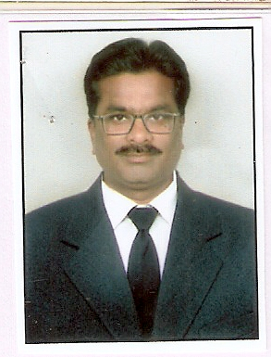 | 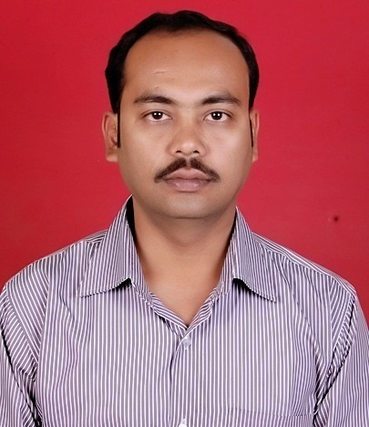 | 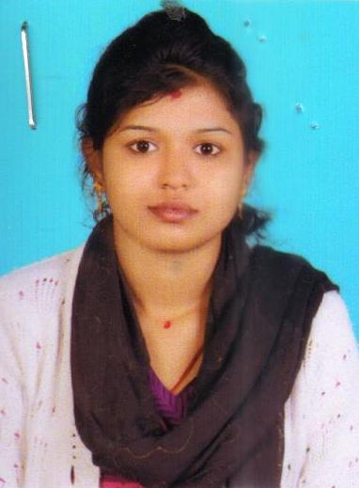
PROF. T.RAMESH  PROFESSOR (HOD)  P.Hd, M.TECH, B.TECH  BPUT REGD NO. T142736201  DOJ. 13.10.2017  EXPERIENCE- 15 YRS | Mr. SRINIBAS NANDA  ASSOCIATE PROFESSOR  M.TECH, B.TECH  BPUT REGD NO. T151736201  DOJ. 02.02.2015  EXPERIENCE- 09 YRS | MRS. DIPIKA RAULO  ASSISTANT PROFESSOR  M.TECH, B.TECH  BPUT REGD NO. T171362321  DOJ. 17.10.2017  EXPERIENCE- 06 YRS
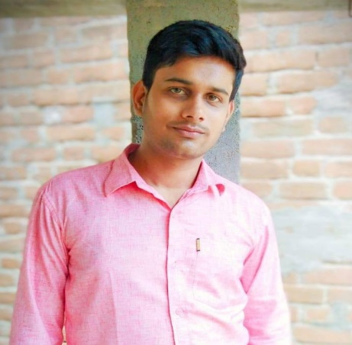 | 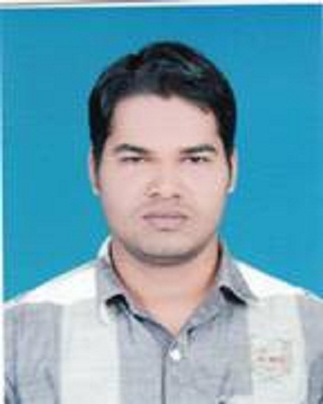 | 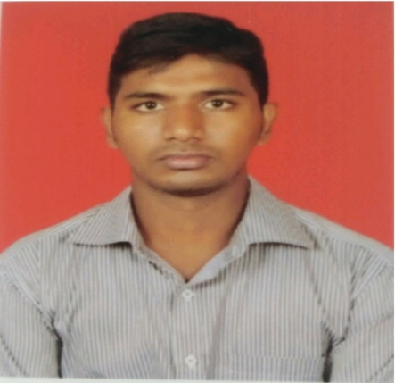
MR. DHIREN KU. PATTNAYAK  ASSISTANT PROFESSOR  M.TECH, B.TECH  BPUT REGD NO. T171362324  DOJ. 08.01.2016  EXPERIENCE- 07 YRS | MR. ABINASH SWAIN  ASSISTANT PROFESSOR  M.TECH, B.TECH  BPUT REGD NO. T171362326  DOJ. 08.01.2016  EXPERIENCE- 07 YRS | MR. BAIDURJYA PRADHAN  ASSISTANT PROFESSOR  M.TECH, B.TECH  BPUT REGD NO. T171362331  DOJ. 09.12.2019  EXPERIENCE- 04 YRS
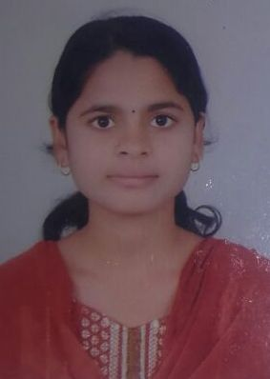 | 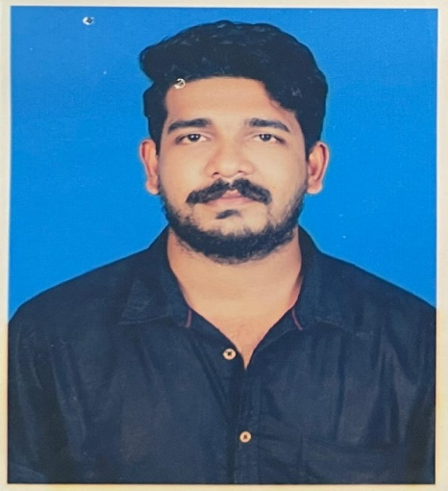 | 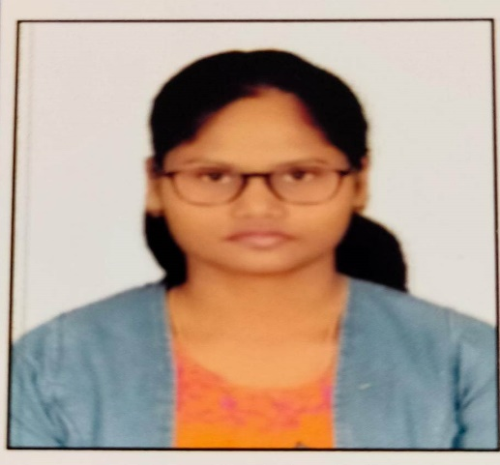
MRS. PUJARANI DASH  ASSISTANT PROFESSOR  M.TECH, B.TECH  BPUT REGD NO. T171362503  DOJ. 22.05.2017  EXPERIENCE- 06 YRS | MR. NABIN KISHORE GANTAYET  ASSISTANT PROFESSOR  M.TECH, B.TECH  BPUT REGD NO. T173620165  DOJ. 22.05.2017  EXPERIENCE- 06 YRS | MISS. T. CHANTI  ASSISTANT PROFESSOR  M.TECH, B.TECH  BPUT REGD NO. T2101362022  DOJ. 22.01.2020  EXPERIENCE- 03 YRS
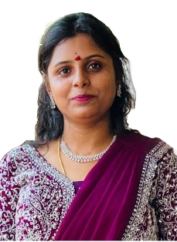 | 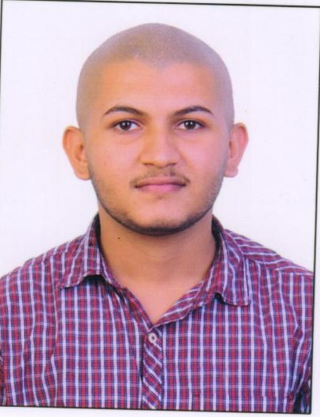 | 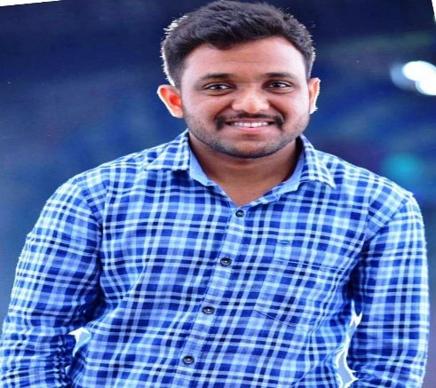
MISS. K. SRILEKHA  ASSISTANT PROFESSOR  M.TECH, B.TECH  BPUT REGD NO. T220136204  DOJ. 30.09.2021  EXPERIENCE- 02 YRS | MR. AUROBINDO RATH  ASSISTANT PROFESSOR  M.TECH, B.TECH  BPUT REGD NO. T171362316  DOJ. 08.10.2016  EXPERIENCE- 07 YRS | MR. PRASANT KU. RATNALU  ASSISTANT PROFESSOR  M.TECH, B.TECH  BPUT REGD NO. T200136201  DOJ. 14.09.2020  EXPERIENCE- 03 YRS
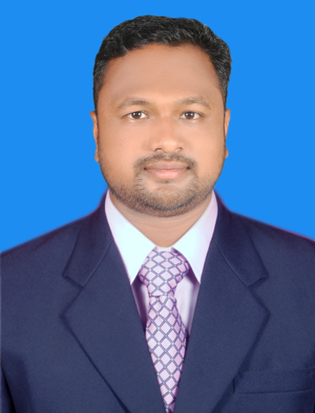 | 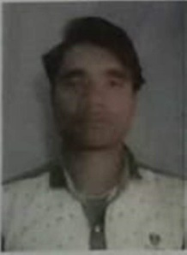 | 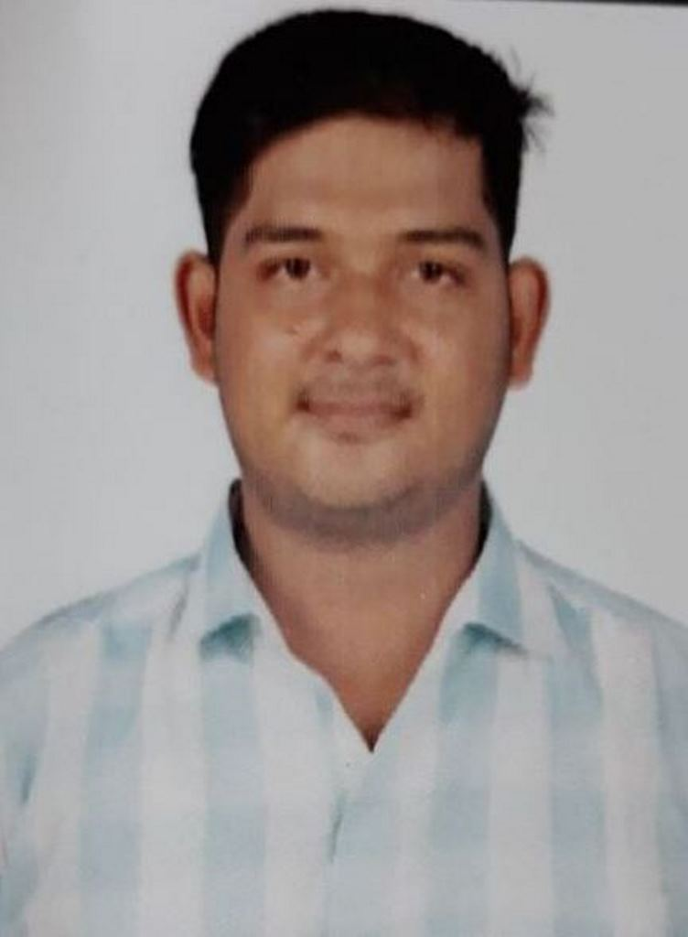
MR. SANTOSH KU. MANDANGI  ASSISTANT PROFESSOR  M.TECH, B.TECH  BPUT REGD NO. T173622981  DOJ. 11.02.2020  EXPERIENCE- 03 YRS | MR. SASHIDEV NAIK  ASSISTANT PROFESSOR  M.TECH, B.TECH  BPUT REGD NO. T171362316  DOJ. 10.12.2020  EXPERIENCE- 03 YRS | MR. AYASHKANTA RANASINGH  ASSISTANT PROFESSOR  M.TECH, B.TECH  BPUT REGD NO. T220136201  DOJ. 17.05.2017  EXPERIENCE- 06 YRS

Faculty Profile (MECHANICAL ENGINEERING)

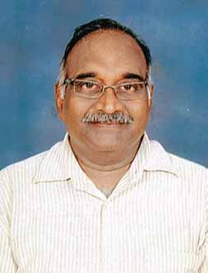 | 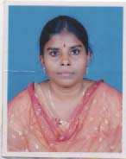 | 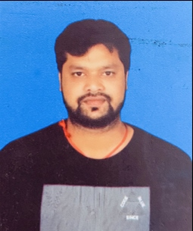
PROF. S. SRINIVASAN  PROFESSOR (PRINCIPAL)  PHd, ME  BPUT REGD NO. T151736201  DOJ. 30.04.2017  EXPERIENCE- 31 YRS | MRS. GORLI MANGAMA  ASSOCIATE PROFESSOR  M.TECH, B.TECH  BPUT REGD NO. T1713620173  DOJ. 17.102017  EXPERIENCE- 13 YRS | MR. SURYAKANTA SARANGI  ASSISTANT PROFESSOR  M.TECH, B.TECH  BPUT REGD NO. T173620159  DOJ. 01.08.2016  EXPERIENCE- 08 YRS
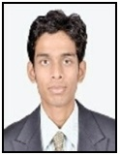 | 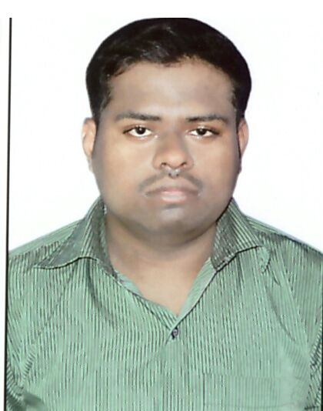 | 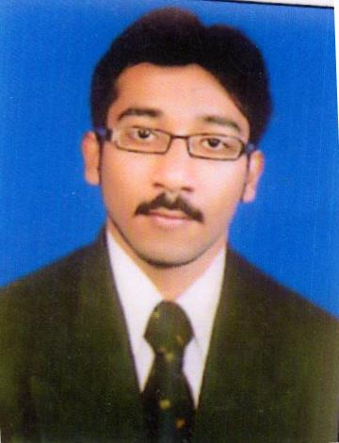
MR. MADHUSUDAN PUROHIT  ASSISTANT PROFESSOR  M.TECH, B.TECH  BPUT REGD NO. T171362322  DOJ. 21.10.2017  EXPERIENCE- 06 YRS | MR. UDIYA PRASAD SETHY  ASSISTANT PROFESSOR  M.TECH, B.TECH  BPUT REGD NO. T171362329  DOJ. 18.05.2017  EXPERIENCE- 06 YRS | MR. SUMIT PRASAD PATNAIK  ASSOCIATE PROFESSOR  M.TECH, B.TECH  BPUT REGD NO. T143136201  DOJ. 08.10.2020  EXPERIENCE- 07 YRS
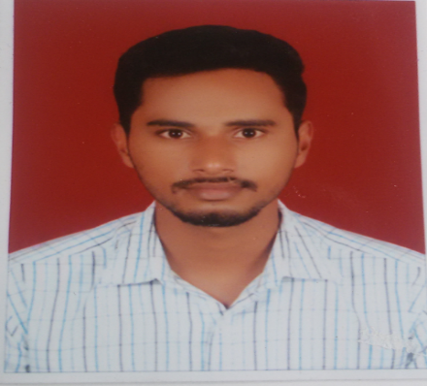 | 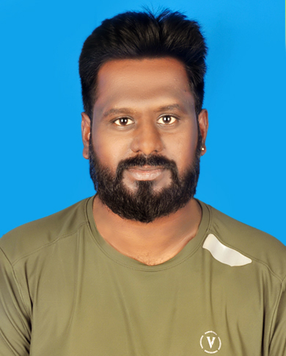 | 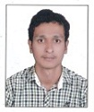
MR. SIMANCHAL BISOI  ASSISTANT PROFESSOR  M.TECH, B.TECH  BPUT REGD NO. T173620183  DOJ. 16.05.2017  EXPERIENCE- 07 YRS | MR. SANTOSH KUMAR CHINNARY  ASSISTANT PROFESSOR  M.TECH, MBA, B.TECH  BPUT REGD NO. T1210136203  DOJ. 21.10.2022  EXPERIENCE- 01 YRS | MR. AUROBINDA PANDA  ASSISTANT PROFESSOR  M.TECH, B.TECH  BPUT REGD NO. T171362319  DOJ. 18.05.2017  EXPERIENCE- 06 YRS
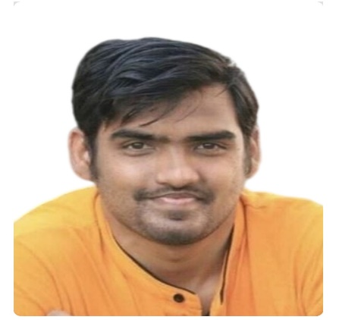 | 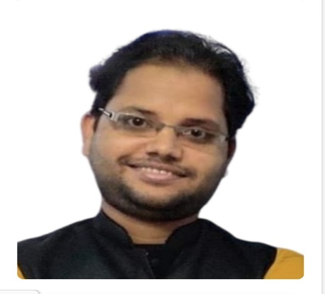 | 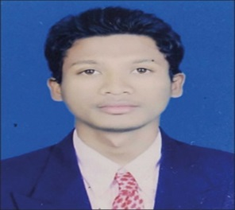
MR. SUBRAT KUMAR MISHRA  ASSISTANT PROFESSOR  M.TECH, B.TECH  BPUT REGD NO. T220136203  DOJ. 02.08.2022  EXPERIENCE- 01 YRS | MR. GAGANA BIHARI MAHARANA  ASSISTANT PROFESSOR  M.TECH, B.TECH  BPUT REGD NO. T220136205  DOJ. 18.02.2022  EXPERIENCE- 01 YRS | MR. JOGESWAR PUNJI  ASSISTANT PROFESSOR  M.TECH, B.TECH  BPUT REGD NO. T141736201  DOJ. 09.01.2020  EXPERIENCE- 04 YRS
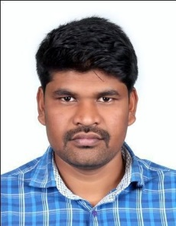 | 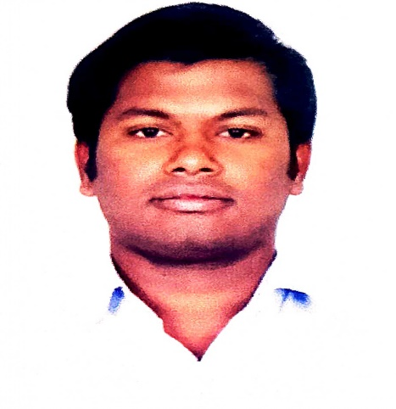 | 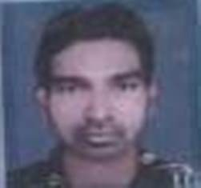
MR. PITAMBAR GOUDA  ASSISTANT PROFESSOR  M.TECH, B.TECH  BPUT REGD NO. T171362323  DOJ. 16.09.2020  EXPERIENCE- 03 YRS | MR. BABLU CHATRIA  ASSISTANT PROFESSOR  M.TECH, B.TECH  BPUT REGD NO. T220936202  DOJ. 14.09.2020  EXPERIENCE- 03 YRS | MR. GIRIDHARI PALKIA  ASSISTANT PROFESSOR  M.TECH, B.TECH  BPUT REGD NO. T171362320  DOJ. 10.05.2020  EXPERIENCE- 03 YRS

MISS. ARUNA PANI
ASSISTANT PROFESSOR
M.TECH, B.TECH
BPUT REGD NO. T220536216
DOJ. 08.02.2021
EXPERIENCE- 03 YRS

Faculty Profile (ELECTRICAL AND ELECTRONICS ENGINEERING)
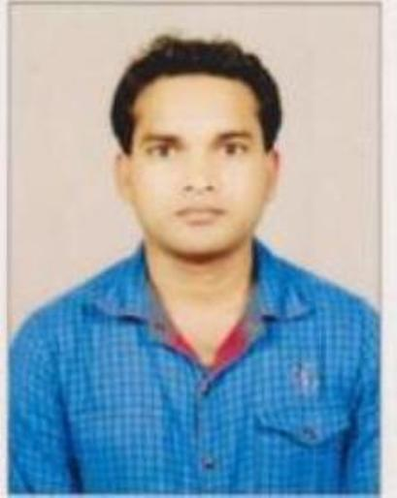 | 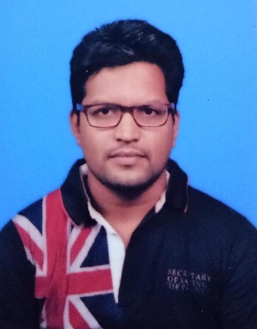 | 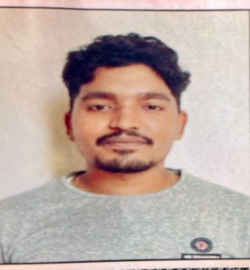
Mr.SRABAN KUMAR KANDHPAN  ASSOCIATE PROFESSOR (HOD)  M.TECH, B.TECH  BPUT REGD NO.  T173620133  DOJ. 11/01/2014  EXPERIENCE- 10yr | Mr.ASHISH KUMAR NAYAK  ASSOCIATE PROFESSOR  M.TECH, B.TECH  BPUT REGD NO. T173620170  DOJ. 20/09/2014  EXPERIENCE- 10yr | Mr.ABHIJIT KUMAR NAYAK  ASSISTANT PROFESSOR  M.TECH, B.TECH  BPUT REGD NO. T173620164  DOJ. 22/05/2017  EXPERIENCE- 7yr
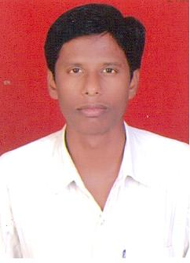 | 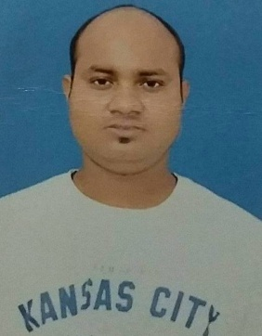 | 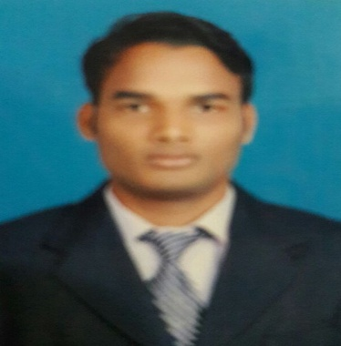
Mr.PRASANT KUMAR SANKHUA  Assistant Professor  M.Tech  BPUT REGD NO.  T151836201  DOJ.11/09/2014  EXPERIENCE- 10yr | Mr.ANIKET RAJ  ASSISTANT PROFESSOR  M.TECH, B.TECH  BPUT REGD NO. T173620189  DOJ. 16/05/2017  EXPERIENCE- 7yr | Mr.ABHISEK NAYAK  ASSOCIATE PROFESSOR  M.TECH, B.TECH  BPUT REGD NO. T171362326  DOJ. 15/05/2017  EXPERIENCE- 7yr
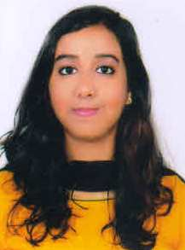 | 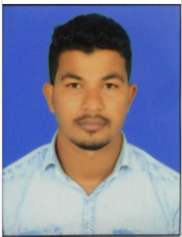 | 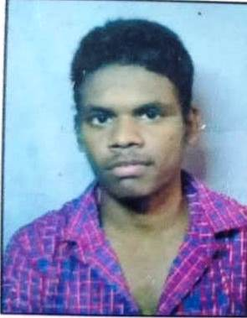
Mr.AISWARYA NARAYANACH ETTY  ASSISTANT PROFESSOR  M.TECH, B.TECH  BPUT REGD NO.T171362325  DOJ. 12/09/2018  EXPERIENCE- 06 YRS | Mr.MANAS RANJAN BISWAL  ASSISTANT PROFESSOR  M.TECH, MBA, B.TECH  BPUT REGD NO. T171362318  DOJ. 26/10/2020  EXPERIENCE- 04 YRS | Mr.PRABIN KUMAR CHATRIA  ASSISTANT PROFESSOR  M.TECH, B.TECH  BPUT REGD NO.T161336201  DOJ. 09/08/2020  EXPERIENCE- 04 YRS

Faculty Profile (BASIC SCIENCE AND HUMANITICS)
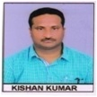 | 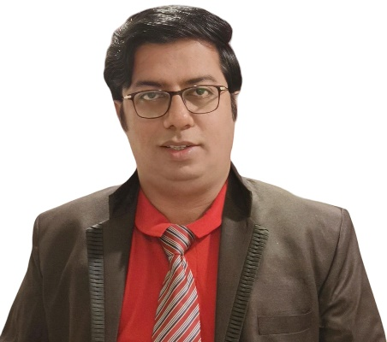 | 
PROF. KISAN KUMAR  PROFESSOR  (HOD)  M.Sc (Math), P.Hd  BPUT REGD NO. T111236201  DOJ. 29.09.2010  EXPERIENCE-19 YRS | PROF. SANATA KUMAR PANDA  ASSOCIATE PROFESSOR  M.TECH (CS), MCA  BPUT REGD NO. T111336201  DOJ. 08.02.2010  EXPERIENCE- 14 YRS | MISS. JAYALAXMI SUBUDHI  ASSOCIATE PROFESSOR  MBA (HR)  BPUT REGD NO. T1713623082  DOJ. 16.05.2017  EXPERIENCE-10 YRS
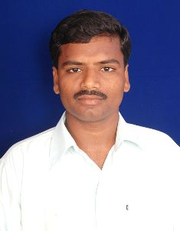 | 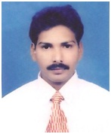 | 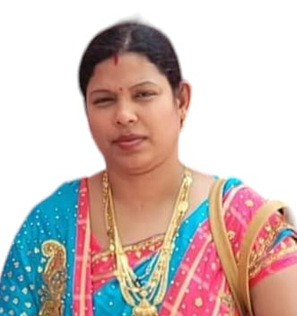
PROF. B.RAJ KUMAR  ASSOCIATE PROFESSOR  M.A (ENGLISH), M.Phil, P.Hd  BPUT REGD NO. T161336201  DOJ. 08.10.2015  EXPERIENCE- 15 YRS | PROF. B.V.RAVI KUMAR  PROFESSOR  MBA (FINANCE), P.Hd  BPUT REGD NO. T171362327  DOJ. 24.10.2012  EXPERIENCE-16 YRS | MISS. KUNI KUMARI PALO  ASSOCIATE PROFESSOR  MA (ECONOMICS)  BPUT REGD NO. T179362001  DOJ. 25.06.2013  EXPERIENCE-11 YRS
 | 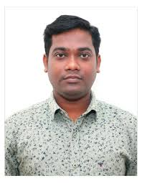
MISS. CHARCHITA PATRO  ASSISTANT PROFESSOR  MBA (HR, FINANCE)  BPUT REGD NO. T171362328  DOJ. 15.09.2020  EXPERIENCE-05 YRS | MR. MITHUN CH. KOUSALYA  ASSISTANT PROFESSOR  MCA  BPUT REGD NO. T171362502  DOJ. 08.02.2010  EXPERIENCE- 14 YRS

BALANCE SHEET
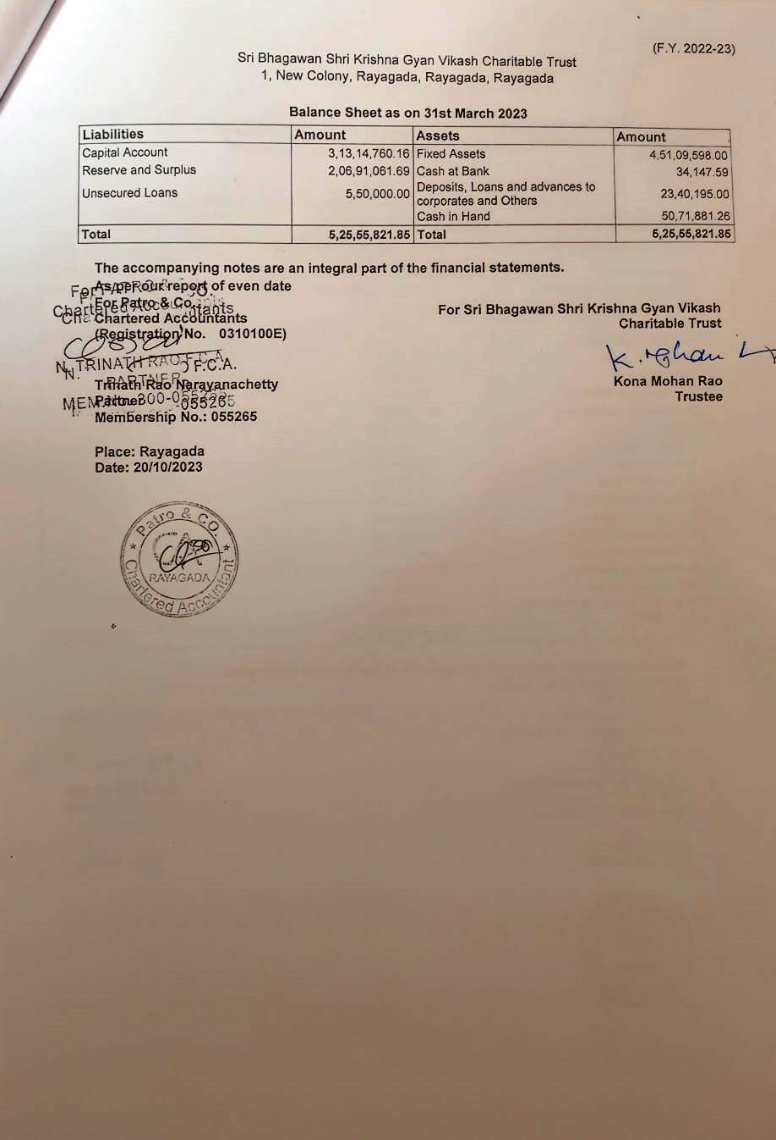

NBA ACCREDITATION STATUS
1 | Programmes/ Courses Accredited | NOT APPLIED
2 | Applied for Accreditation | NOT APPLIED
 | - Applied but Visit not Happened | NOT APPLIED
 | - Visit Happened but result awaited | NOT APPLIED

NAAC ACCREDITATION STATUS
1 | Accredited | NOT APPLIED
2 | Applied for Accreditation | NOT APPLIED
 | - Applied but Visit not Happened | NOT APPLIED
 | - Visit Happened but result awaited | NOT APPLIED

